HOW MUCH DO YOU KNOW ABOUT THE IELTS EXAM?
- There’s no such thing as a pass or fail in IELTS. TRUE OR FALSE?
- Only speakers with British accents are used in the listening test. TRUE OR FALSE?
- How do you receive your IELTS results?
a] on the phone b] by fax c] by letter d] by email
- Students can have their tests remarked if they pay for it. TRUE OR FALSE?
- The General Training Module is for those wishing to study at undergraduate level. TRUE OR FALSE?
- The listening and speaking papers are the same for both the Academic Module and the General Training Module. TRUE OR FALSE?
- Both the reading and listening papers allow 10 minutes for students to transfer their answers from the question paper to the answer sheet. TRUE OR FALSE?
- The listening test has four parts. Write 1-4 in Column A according to the order in which the parts come in the test.
TYPE OF LISTENING MATERIALS
A | B
 | Conversation between up to four people set in an educational or training context (e.g. a university tutor and a student discussing an assignment, or a group of students planning a research project)
 | Monologue on an academic subject (e.g. a university lecture.
 | Conversation between two people set in an everyday social context (e.g. a conversation in an accommodation agency)
 | Monologue set in an everyday social context (e.g. a speech about local facilities or a talk about the arrangements for meals during a conference.
- In the reading paper texts are taken from real books, magazines or newspapers.
- In the reading exam the meanings of specialist technical words (e.g. medical or engineering words) are given in the question paper. TRUE OR FALSE?
- In the Academic Module Writing Paper Task 2, which of the following essay question types will not come:
a] Describing a solution to a problem
b] Describing a person or a holiday
c] Giving a reasons for an opinion
d] Comparing and contrasting two different ways of doing something

- In the speaking test students are allowed to take notes in Part 2 of the test. TRUE OR FALSE?
- In both the listening and reading tests students can write their answers in either lower case or capitals. TRUE OR FALSE?
- In the reading and listening tests students’ answers written on the question papers are marked. TRUE OR FALSE?
- In the listening test students always have to spell names without a single mistake to get a mark. TRUE OR FALSE?

- In the reading test there are twelve question types. Write the correct letter A] – L] on the lines next to the corresponding question types in the table below.
1. Sentence Completion _____ 7. Yes / No / Not given _____
2. Choosing from a list _____ 8. Multiple Choice _____
3. Summary Completion _____ 9. Paragraph Content _____
4. Table Completion _____ 10. Paragraph Headings _____
5. Notes Completion _____ 11. Labelling a picture _____
6. Classification _____
A | B
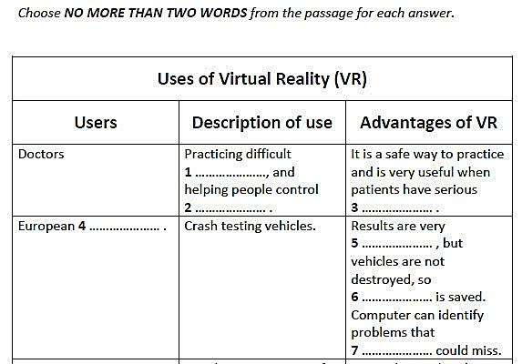 | Do the following statements agree with the views of the writer? Write:  YES if the statement agrees with the views of the writer  NO if the statement contradicts the views of the writer  NOT GIVEN if it is impossible to say what the writer thinks about this  35 It is easy to describe what libraries are.  36 It is difficult to determine the future of libraries.  37 Libraries have become much more technologically advanced.
C | D
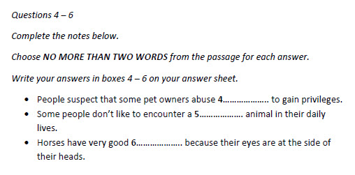 | 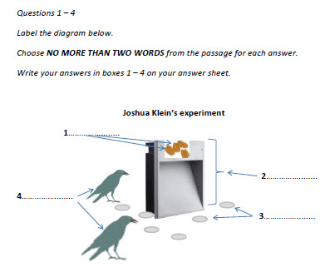

E | F
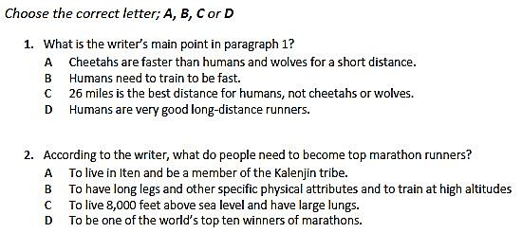 | 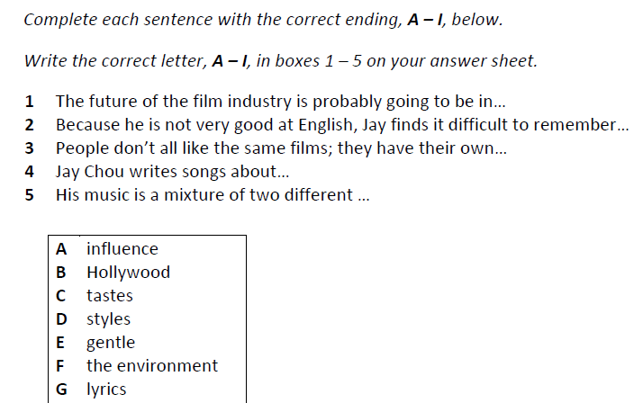
G | H
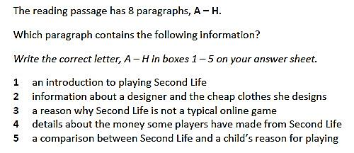 | Complete the sentences below. Choose NO MORE THAN TWO WORDS from the text for each answer.  Jay Chou started out as a musician, but he loves movies, which he says are a source 6______ to him. He still has enough time to 7______ although his new record won’t be finished before 8______. He didn’t like to say no when good production teams 9______ him to work on a film. He promises to make a new record 10______.
I | J
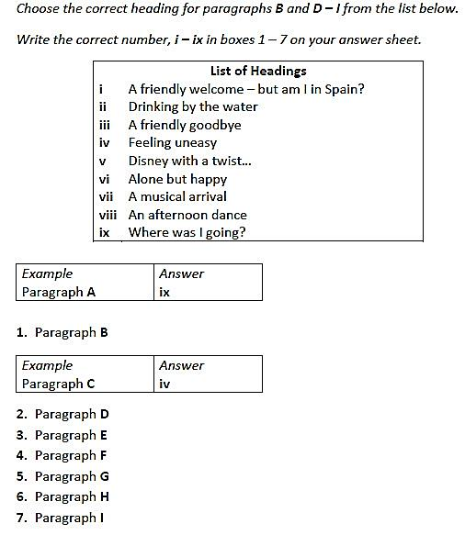 | 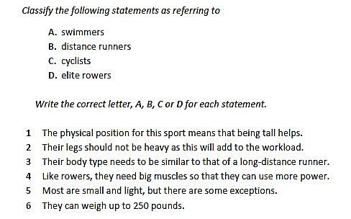

K

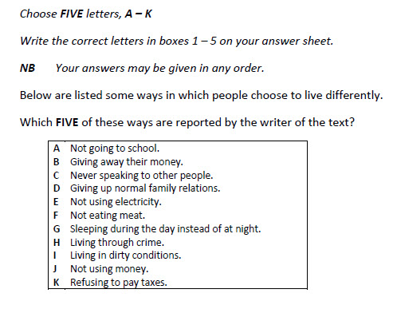

Now answer these questions about the 12 different types of READING exam question. The SAME question type can have more than ONE question.
Example: Which question type(s) are asking whether statements agree with or contradict information in the text? True / False / Not Given and Yes / No / Not Given
- In which question type(s) is there more than one correct answer?
___________________________________________________________________
- In which question type(s) do you choose up to two words from the text?
___________________________________________________________________
- In which question type(s) do you have to put sentences about the text into categories? ___________________________________________________________________
- In which question type(s) are three choices given for the answer?
___________________________________________________________________
- In which question type(s) do you match paragraphs with phrases describing what’s in those paragraphs?
___________________________________________________________________
- In which question type(s) are there four answer choices?
___________________________________________________________________
- In which question type(s) do you have to finish sentences which are about the text with words in a box? ___________________________________________________________________
- In which question type(s) do you complete a paragraph with words from the text?
___________________________________________________________________
- In which question type(s) do you write words describing a picture?
___________________________________________________________________
- In which question type(s) is the order in which you put the answers NOT important?
___________________________________________________________________
- In which question type(s) are notes about the text completed with words from the text?
___________________________________________________________________

IELTS LISTENING QUESTION TYPES
- Match the question types 31 - 36 with the correct picture of each one. Write the correct letter A – G on the lines below. There are TWO examples of ONE question type.
- Labelling a Floor Plan ____ 7. Labelling a Flow Chart ____
- Short Answer ____ 8. Multiple choice ____
- Notes Completion ____
- Sentence Completion ____
- Matching ____
- Form Completion ____
B
A
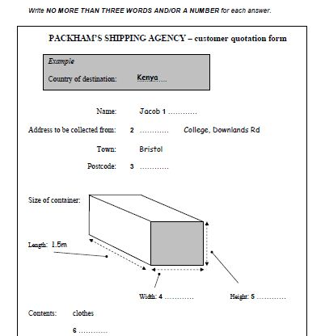 | 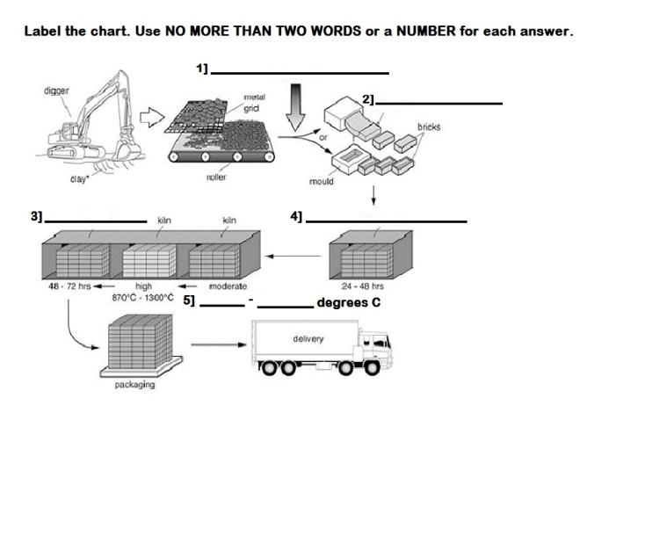
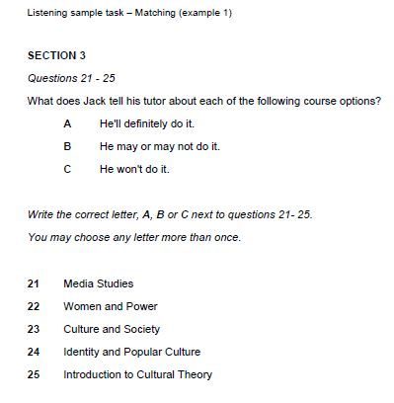  C |  | 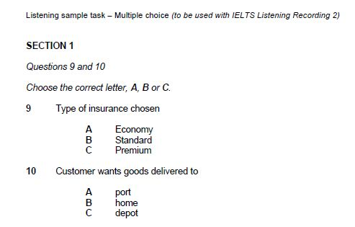  D
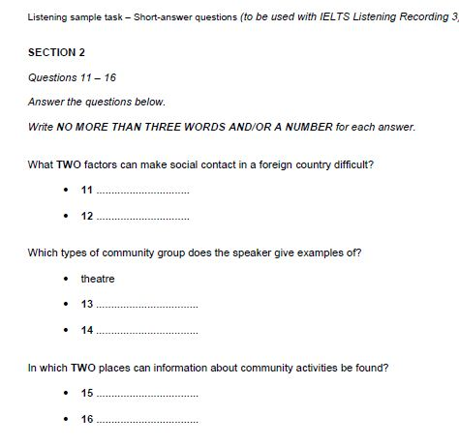  E |  | 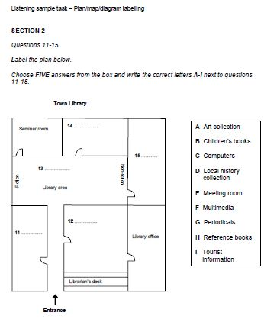  F
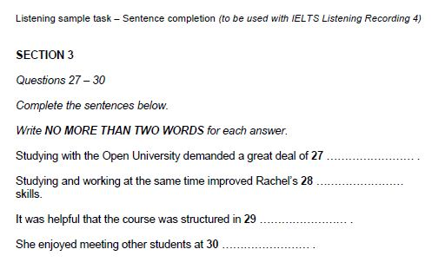
G
H
Answer the questions below; some of the questions may have MORE THAN ONE answer.
- There are 30 questions on the IELTS listening test, which is divided into four parts. TRUE OR FALSE?
- In which type[s] of the listening questions do you choose your answer?
- Which type of diagram shows the stages of a process?
- In which type[s] of listening questions do you either complete sentences with words from the listening text or from a list?
- Multiple-choice questions in the IELTS listening test can have either THREE or FOUR options. TRUE OR FALSE?
- The IELTS listening test is in different formats in the Academic and General Training Modules. TRUE OR FALSE?
- If you only give SOME of the correct information in an answer where you have to write words, you’ll always get zero marks. TRUE OR FALSE?

