LISTENING TEST 8 – FULL SCRIPT

IELTS Listening 8 - Section 1

Questions 1-5
Circle the appropriate letters A-D.
Now Listen carefully and answer Questions 1 to 5
1) | How long did Hannah think it would take her to find a place to live?
 | A three weeks
 | B less than three weeks
 | C more than three weeks
 | D more than four weeks

2) | There is not enough accommodation to rent because
 | A it is the end of the academic year.
 | B Hannah is a new student.
 | C the area has lots of new technology companies.
 | D the town is small.

3) | £400 a month for rent is
 | A higher than Hannah has paid before.
 | B lower than Hannah has paid before.
 | C not cheap for the area.
 | D cheap for the area.

4) | At the moment Hannah is living
 | A in a hostel.
 | B in a suitcase.
 | C in a hotel.
 | D in a flat.

5) | Hannah's new flat
 | A is a bit noisy.
 | B is on the second floor.
 | C has two bedrooms.
 | D has a large roof terrace.

Questions 6 and 7
Complete Dad's note.
Hannah's address:
6) ........................................ Whitehart Road
7) ........................................ 9RJ.

Questions 8-10
Write NO MORE THAN THREE WORDS to complete each space.
8) Hannah plans to travel to her parents' house on Friday .........................................
9) Hannah's Dad will return the van on .........................................
10 The journey time is about .........................................

SECTION 2

QUESTIONS 11 – 14

Circle FOUR letters A-H.
Which FOUR planned developments are mentioned?
A a village town hall
B a leisure centre
C a play area for children
D a hospital
E an industrial development
F extra houses
G a steel works
H a motorway

Questions 15-18
Tick Column A if the individual is in favour of the proposals.
Tick Column B if the individual is against the proposals.
 | A | B
Example: The local farmer |  | ✓
15) The Mayor
16) The conservation group spokesman
17) The local MP
18) The local shopkeeper

Questions 19 and 20
Circle the correct Ietter A-D.
19) | Upton is
 | A close to Tartlesbury.
 | B far from Tartlesbury.
 | C connected by rail to Tartlesbury.
 | D a town with a university.

20) | The College has
 | A never had a 100% success rate.
 | B had a 100% success rate this year.
 | C always been very successful.
 | D never been successful.

IELTS Listening 8 - Section 3

Write NO MORE THAN FOUR WORDS or A NUMBER for each answer.

21) How many essays do the students have to write? .....................
22) What percentage does the written exam account for? .....................
23) How many marks did Carl get for his latest essay? .....................
24) How many marks did Pamela get for her latest essay? .....................
25) When was the marking system explained before? .....................

Questions 26-30
Complete the table below.
Write NO MORE THAN THREE WORDS for each answer.
 | Carl | Pamela
Research | Very good, lots of 26) ....................examples | Very good
Sources | Very sound | Very good
Organization | Very good | 29) ....................
Writing style | 27) .................... | Slightly too informal in some places
Previous essay | Disappointing, but rewrite 28).................... | 30) ..................

IELTS Listening 8 - Section 4

Questions 31-35
Circle the correct letters A-D.
31) | The total number of lectures mentioned by the lecturer is
 | A ten.
 | B thirteen.
 | C six.
 | D eight.

32) | The lunch break of the average British worker is
 | A on the increase.
 | B shorter than it used to be.
 | C 36 minutes.
 | D precisely 30 minutes.

33) | Which graph shows the change as regards sick leave?
 | 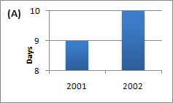
 | 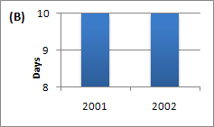
 | 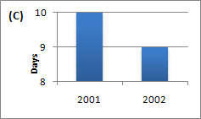
 | 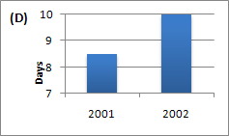

34) | There will be another lecture on stress in work and study
 | A given by Professor Butt.
 | B on the calendar.
 | C in about a fortnight.
 | D in a week's time.

35) | Which of the following is mentioned?
 | A Most workers say they do not take all their holidays.
 | B Under half of the workers say they do not take all their holidays.
 | C Employers do not believe workers.
 | D About a third of healthy workers take days off sick

Questions 36-39
Complete the table below.
Write NO MORE THAN THREE WORDS for each answer.
Employees | now working (36) ........................................ physically and mentally

Productivity | up in many (37) ........................................

In 2002, local car plant | vehicle per employee on rise to (38) ........................................

Car industry | once though to be (39) ........................................

Question 40
Choose the correct letter A-D.
40) | Dr Butt asks those students to see him who
 | A want to work at the plant.
 | B have chosen to do the project.
 | C want to write extra essays.
 | D are new.

