Describe the changes in arable crop production between 2006 and 2011; write between 150 and 170 words.
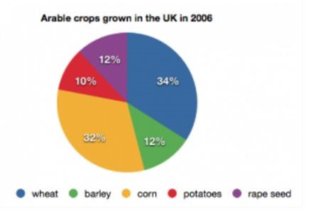 | 




