NAME: _____________________________ ID: ______________
TEST 4 – SECTION 1

► Questions 1 – 10
Complete the form below.
Write NO MORE THAN THREE WORDS AND / OR A NUMBER for each
answer.

ABLE EMPLOYMENT AGENCY
APPLICATION FORM
Full name: | 1 | …………………………………………………….
Address: | 2 | …………………………………………………….
 |  | Melford MF4 5JB
Contact number: | 3 | …………………………………………………….
Qualifications: | (a) | A levels
 | (b) | 4 …………………………………………………..
 | (c) | 5 …………………………………………………..
Previous experience: | (a) | general work in a 6 …………………… (3 months)
 | (b) | Part-time job as a 7 …………………………….....
Interests: | (a) | Member of a 8 …………………………………….
 | (b) | Enjoys 9 ……………………………….(10 years)
Date available: | 10 | ……………………………………………………..

-- - --
TRAIN STATION
TEST 4 – SECTION 2

► Questions 11 – 20
Questions 11 – 16
Complete the sentences below.
Write NO MORE THAN TWO WORDS for each answer.

The hotel
11 You must book ………………………………………………….. in advance.
12 There are some interesting ……………………………………….. in the lounge.

Activities
13 The visit to the …………………………………….. has been cancelled.
14 There will be a talk about ……………………………… from the area on Saturday.
15 The visit to the ……………………………………….. will take place on Sunday.
16 There is a collection of ……………………………………… in the art gallery.

Questions 17 – 20
Label the map below.
Write the correct letter A – I next to questions 17 – 20.
Where are the following places situated?
N
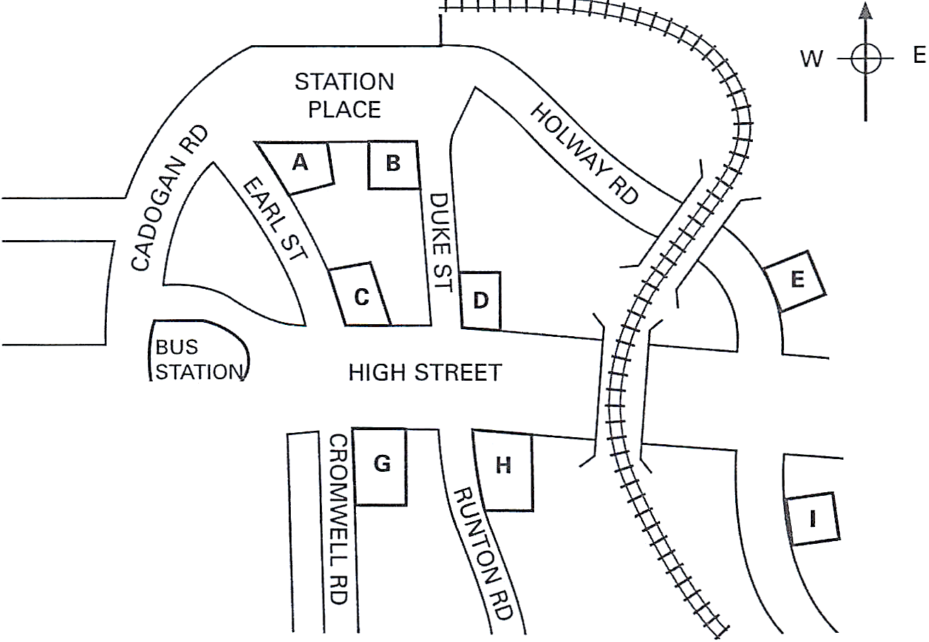
S

17 Park Hotel ………………………..
Cafe 18

18 Internet ………………………..
19 Tourist Information Office ……………………......
20 Royal House Restaurant ……………………….

TEST 4 – SECTION 3

► Questions 21 – 30
Questions 21 – 26
Write the correct letter, A, B or C next to questions 21 – 26.
At which college are the following features recommended?

A at Forth College
B at Haines College
C at both Forth and Haines Colleges

21 student support services
22 residential accommodation
23 on-line resources
24 libraries
25 teaching staff
26 research record

Questions 27 – 30
Choose the correct letter, A, B or C.

27 David is concerned that he may feel
A unmotivated.
B isolated.
C competitive
28 In the future, Dr. Smith thinks David should aim to
A do further research.
B publish articles.
C get teaching work.
29 What does Dr Smith think has improved masters’ study in recent years?
A the development of the internet
B the growth of flexible courses
C the introduction of changes in assessment
30 David would like to improve the way he
A takes notes in lectures.
B writes up assignments.
C manages his time.

TEST 4 – SECTION 4

► Questions 31 – 40

Questions 31 – 37
Complete the table below.
Write NO MORE THAN TWO WORDS for each answer.

Type of writing | Notes | Tips
Short stories | 3 basic styles | start with a  31 ………………………
Non-fiction | Biographies often popular | Tell publishers about your  32 ………………………
Articles | Advice articles work well | write for a  33 ………………………
Poetry | Meaning shouldn’t be too  34 ………………………….. | read your poems aloud
Plays | Movements usually decided by the  35 ………………………….. | learn about acting
Radio | BBC publishes Handbook | try 36 ………………….  First
Children’s literature | Illustrations important | decide on an  37 …………………….

Questions 38 – 40
Choose the correct letter, A, B or C.

38 What is a disadvantage of first person narration in novels?
A It makes it harder for the main character to be interesting.
B It is difficult for beginners to do well.
C It limits what can be described.

39 What is a mistake when writing novels?
A failing to include enough detail
B trying to explain ironic effects
C including too many characters

40 In order to make dialogue seem natural, writers should
A make recordings of real conversations.
B include unfinished sentences.
C break up long speeches.

LISTENING A N S W E R S H E E T
Higher Colleges of Technology, Abu Dhabi Men’s College
IELTS Tests Exam Essentials #4

1 | James Bowen | 22 | C
2 | 4 Lion Road | 23 | A
3 | 09954 721 822 | 24 | B
4 | history diploma | 25 | B
5 | computer skills certificate | 26 | B
6 | hospital | 27 | B
7 | tour guide | 28 | B
8 | swimming club | 29 | B
9 | playing piano | 30 | C
10 | June 28 | 31 | crisis
11 | breakfast | 32 | specialist knowledge
12 | paintings | 33 | definite market
13 | castle | 34 | obvious
14 | famous people | 35 | director
15 | antiques show | 36 | regional stations
16 | old postcards | 37 | age group
17 | E | 38 | C
18 | F | 39 | B
19 | A | 40 | C
20 | D
21 | A

RAW SCORE ……………………… % ………………………

